X User Research Design

What is it about?
The available page show users set of classrooms. Each classroom has a bullet shows the user if it’s private or it needs a password. When users finish a classroom, there is will be a classroom record.
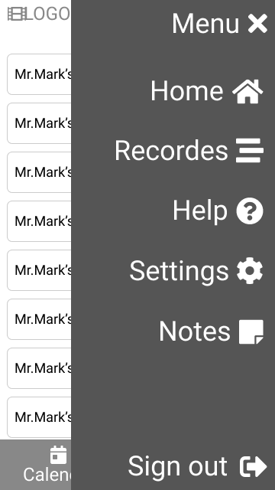
Actions for users to take
Users can decide what they want to attend now. They can either choose a new set of classrooms (can click the classroom to preview if it’s private or not).
Research finding applied to the design
One of the key findings from our user interviews was that users want to record their lectures, so that's why we focused on that feature in this design.
“I enjoy studying both digital and in school. I want to start my own studying - so I record all my lectures.”

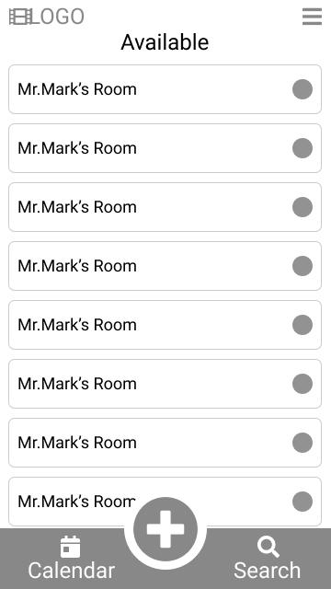
Design Principles
Too many choices lead to choose paralysis
The home page is contained one of Gestalt Principles, it’s “Similarity”.
Design rationale
● Still provide choices to users. Users can control whether they want to attend classroom or watch an record.

